# Problem



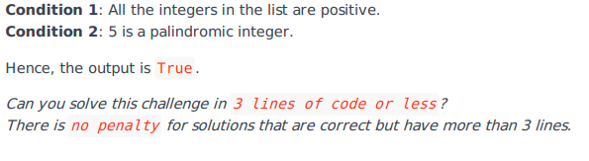

# Josh Solution

# Enter your code here. Read input from STDIN. Print output to STDOUT

N,n = int(input()),input().split()

if all(int(x) > 0 for x in n):

    number=N

    #store a copy of this number

    temp=N

    #calculate reverse of this number

    reverse_num=0

    while(number>0):

        #extract last digit of this number

        digit=number%10

        #append this digit in reveresed number

        reverse_num=reverse_num*10+digit

        #floor divide the number leave out the last digit from number

        number=number//10

    #compare reverse to original number

    print(temp==reverse_num)

# Other solution

N,n = int(input()),input().split()

print(all([int(i)>0 for i in n]) and any([j == j[::-1] for j in n]))